First off, we are NOT exporting Parent WOs (suffix = 000)

Example:

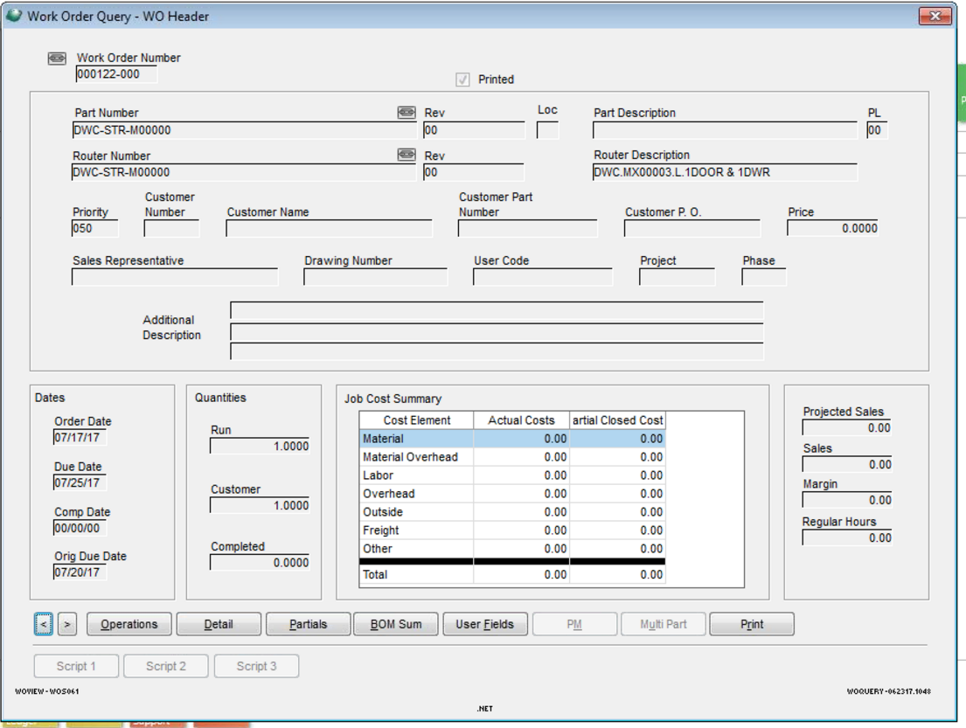

We are Only Exporting Children WOs:

Example:

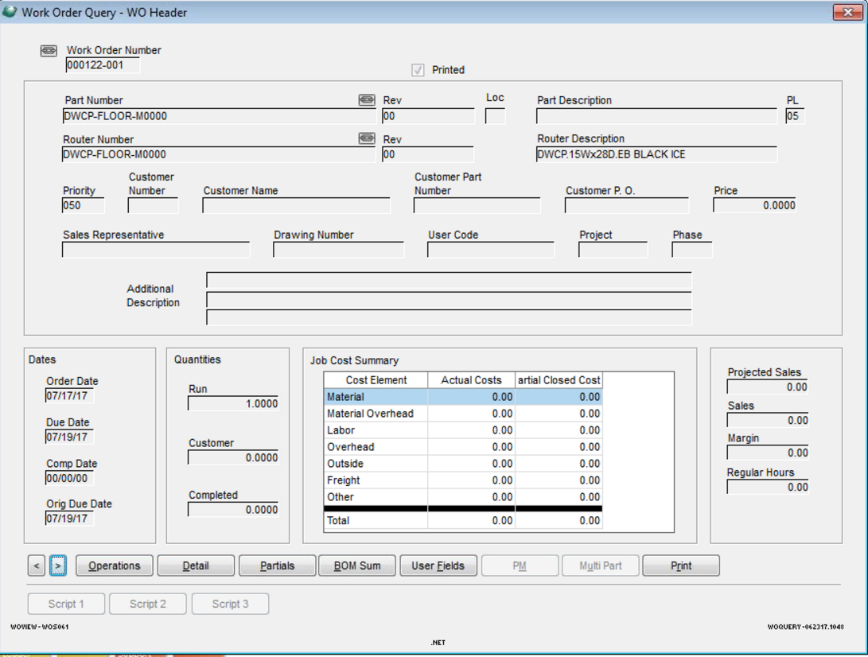

Operations Example of Child WO (excluding Comments):

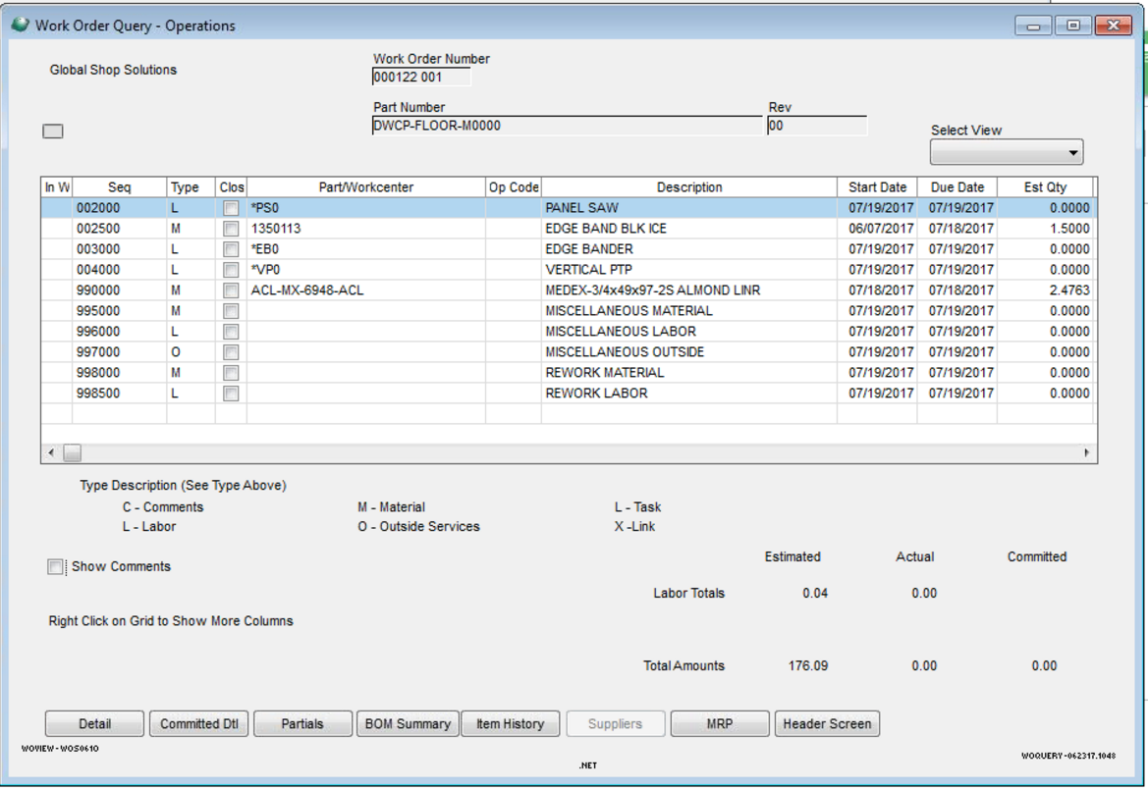

**Selection Process:**

1. Screen will come up with nothing loaded in Grid.

Grid Columns:

Job, Suffix, Part, Rev, Run Qty, WO Priority, Start Date, WC, Customer, Sales Order, Sales order Line, Parent WO-Suffix, Parent Part.

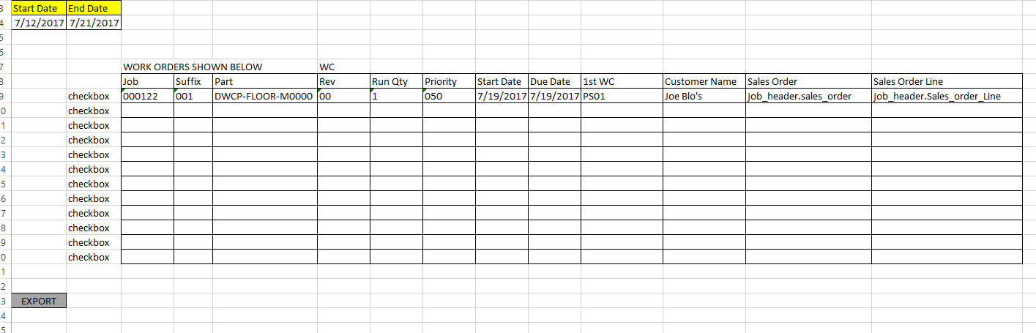

1. Date Range Selection will load the grid (Date range is for First labor Start Date – Scheduled)

Select all OPEN work orders where First “L” operation start date is within date Range selected at top of screen.

-Use APSV3_UBDETAIL and use BDATE to compare against selected date range.

-Grid only shows one record per work order, WC is from scheduled WC in APSV3_UBDETAIL

-only exporting WOs tied to Sales orders

Example query:

*select top 1 Job,Sfx,seq,SAR,BDATE from "APSV3_UBDetail"*

*where job = '000122'*

*and sfx = '001'*

*order by SEQ*

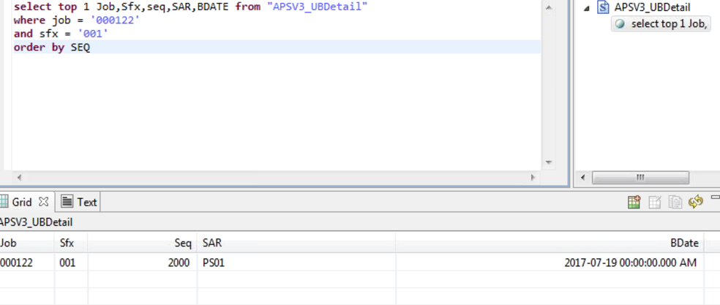

1. We need to compare the data in selection against data ALREADY EXPORTED and NOT show work orders already in the custom table.
   1. GCG_4447_LABEL_DATA (see excel doc)
2. Once data is in grid, need to be able to check multiple(s)/check all, then click export.
3. Export Data – write new records to GCG_4447_LABEL_DATA which stores a record for each piece being made, meaning if WO RUN QTY = 5, then there are 5 records in this table.(see excel for example.)
4. After export routine is complete, then run routine purge for closed work orders.
   1. Check GCG_4447_LABEL_DATA
      1. If WO+SUFFIX is closed in GSS, then delete all records from custom table for those WO+SUFFIX.

**ONLY thing pending right now is the IMAGE_PATH column in the custom table, waiting on info from Sigmanest on where this path is coming from based on Part#.